**ICT Week 2 Lab Task 2**

*Author: Hamza Shahid*

*Roll# 24K-0869*

# Task 2.1: Navigating Directories

## Process

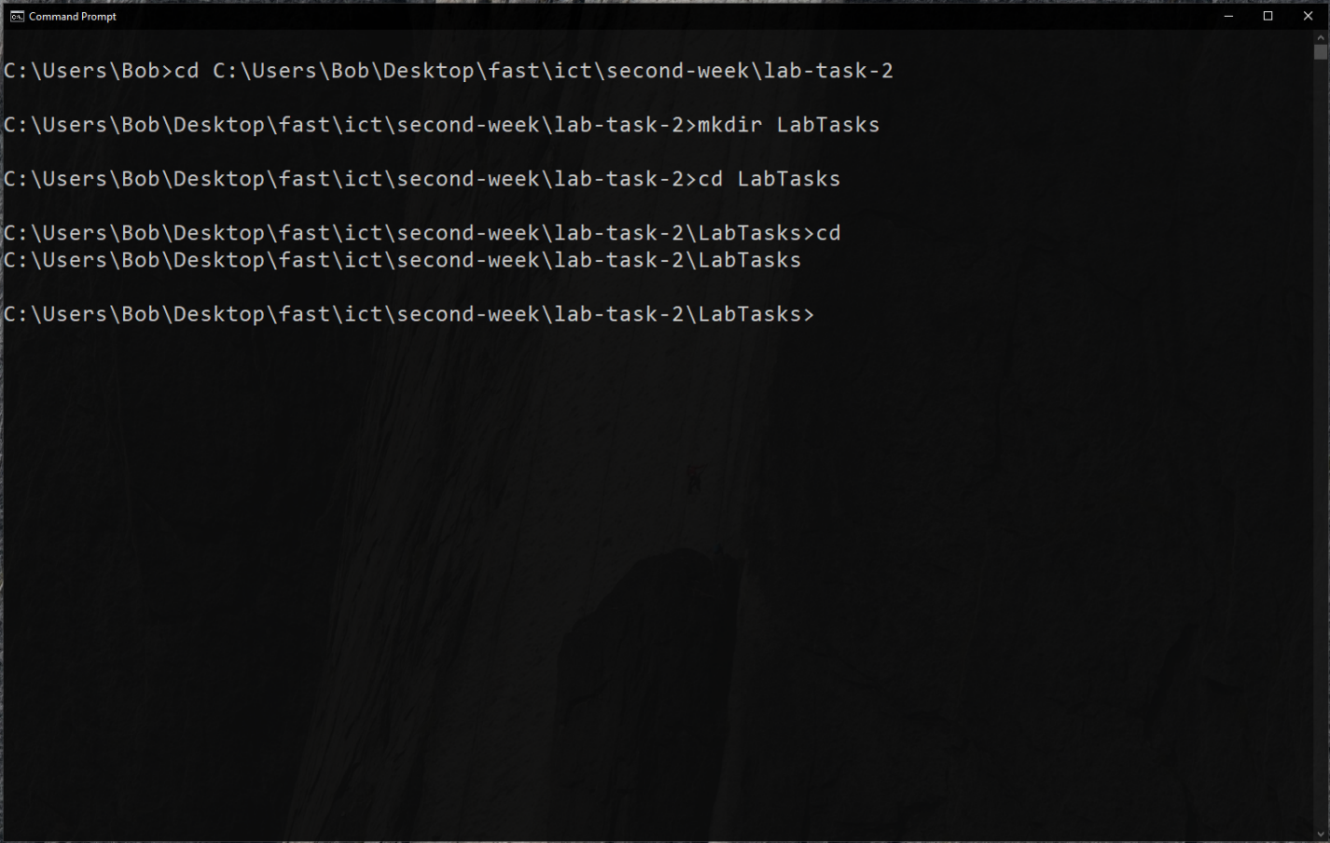

After going to a location using cd we create a folder named LabTasks. We then go into that folder using the same command and ensure task completion using cd .., where .. represents the parent directory.

## Questions

1. **What command did you use to check your current directory?** cd
2. **How can you go back to the previous directory?** cd ..

## Command List

* cd
* mkdir

# Task 2.2: Listing and Managing Files

## Process

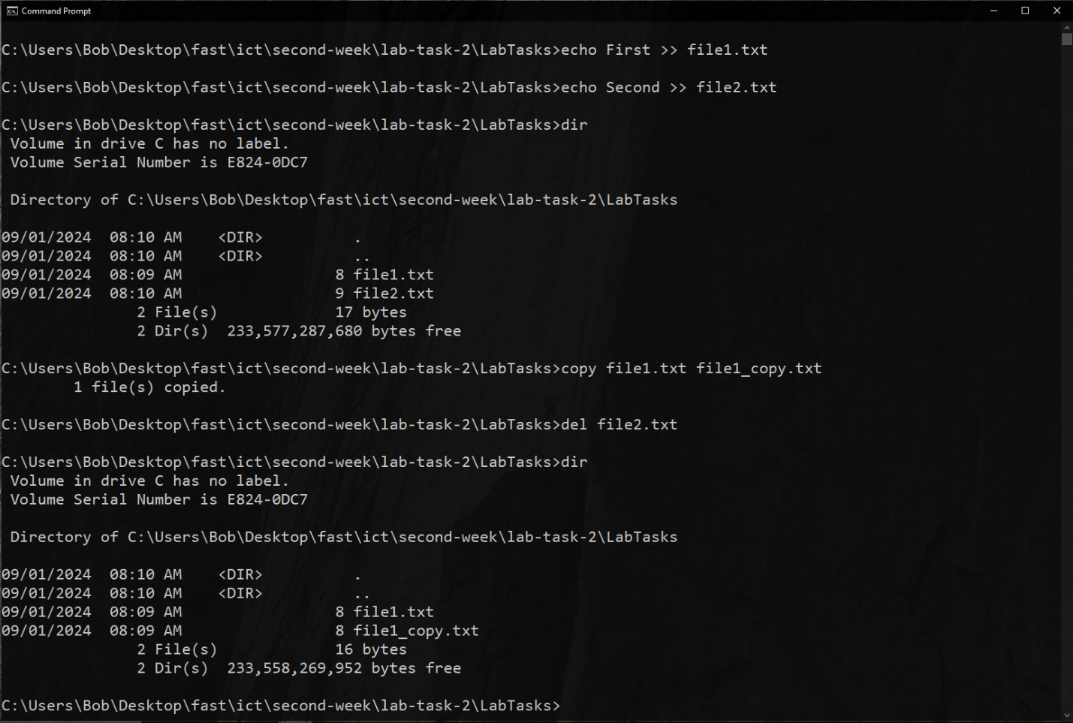

Pretty self-explanatory. Though one thing to note; the >> operator appends to the file while > replaces the contents of the file with the argument(s) to echo. echo also creates the file if it does not exist. Here del is used to delete a file and the copy command’s first argument is the file *source* and second is its *destination*.

## Questions

1. **What does the dir command output show?** It lists all the files and folders in the current directory.
2. **How did you confirm the deletion of file2.txt?** By using the dir command, and seeing the file2.txt line replaced by file1_copy.txt.

## Command List

* echo
* dir
* copy
* del

# Task 2.3: Moving and Removing Directories

## Process

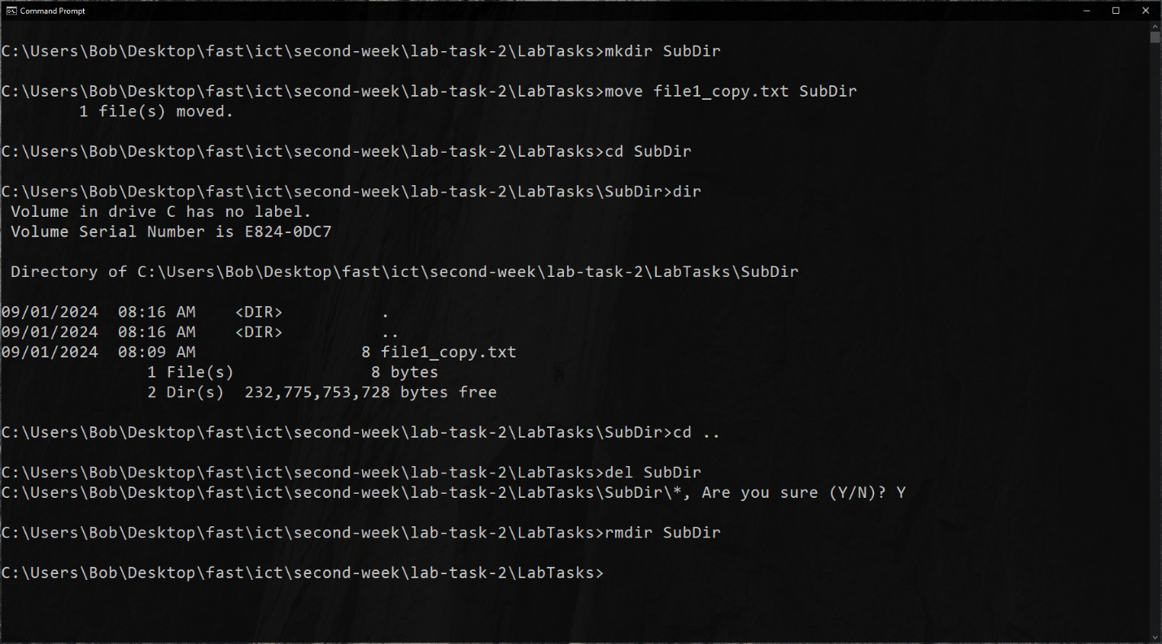

The move command, like copy, takes a *source* and a *destination*. In this case, since the destination is a directory, it moves the source file inside the directory. Now, del when given a file deletes it. However, when given a directory, it deletes all files NOT subdirectories NON-RECURSIVELY (meaning, it does not delete files and directories inside subdirectories) inside its argument directory. On the other hand, rmdir **r**e**m**oves a **dir**ectory only when it is empty.

## Questions

1. **How did you ensure that the directory was empty before using rmdir?** We could use dir, but I preferred to directly del everything inside the subdirectory and hit “Y” to ensure it.
2. **What command did you use to verify the file was moved?** dir with no arguments.

## Command List

* mkdir
* move
* cd
* dir
* del
* rmdir

# Task 2.4/5: Clearing the Command Prompt Screen

## Process

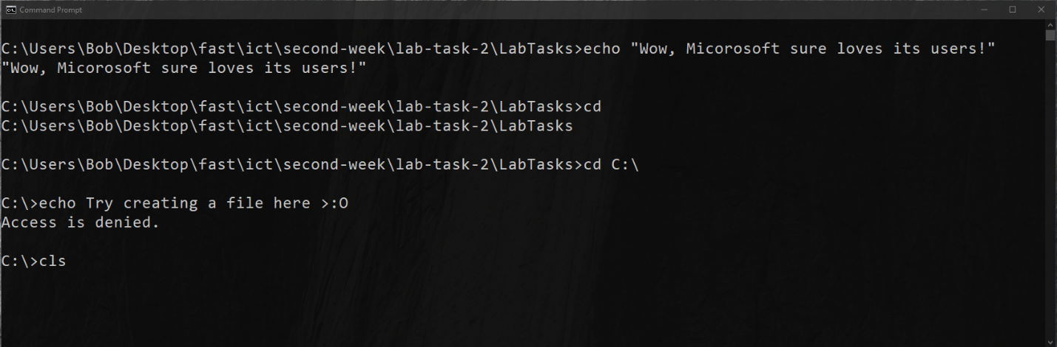

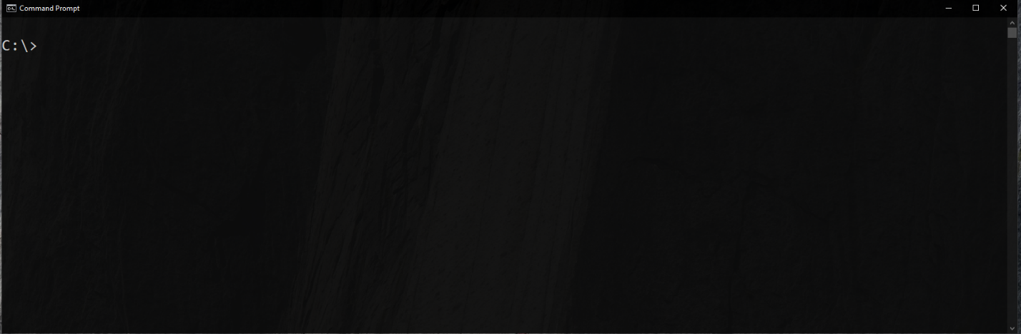

After running some commands, we use the cls command to clear the screen and make way for new commands.

## Questions

1. **How did the cls command affect the display in Command Prompt?** It cleared all previous output and commands.
2. **What is the benefit of using the cls command during a Command Prompt session?** It clears the clutter caused by previous commands and gives space to perform other tasks.

## Command List

* cls (duh)